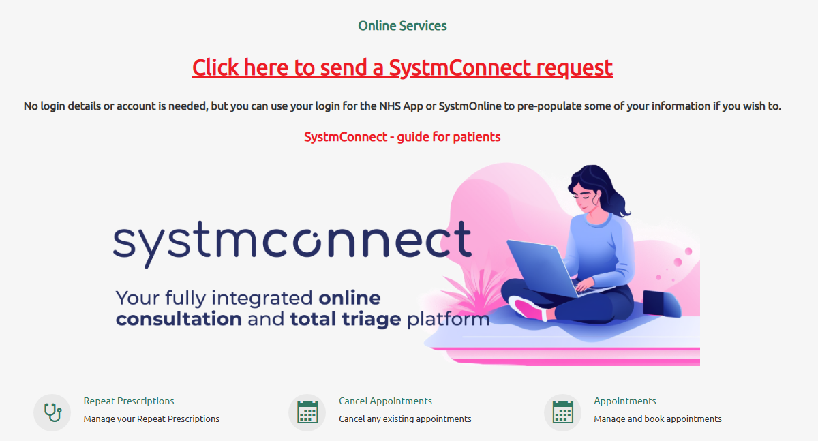
Go to parklands.co.uk via your chosen web browser
Scroll down on the home page and you will find the image below.

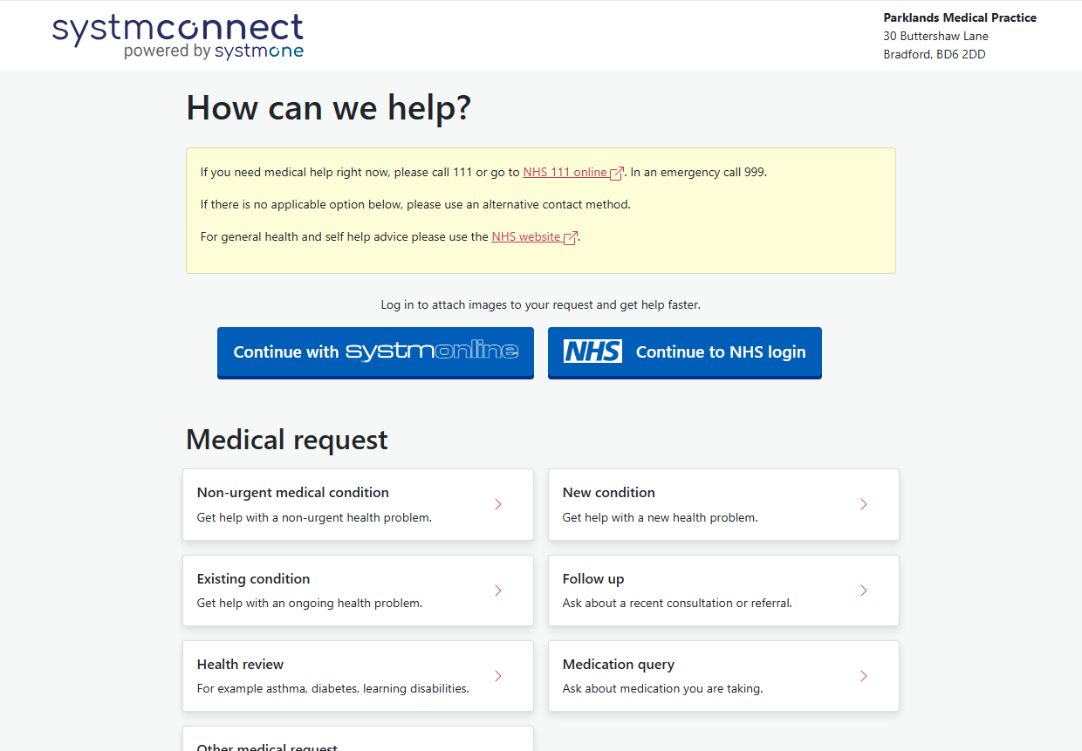
You can Click here to send a SystmConnect request or on the image of the lady holding a laptop. You will then be taken to the SystmConnect page (see image below)

You do not need a username or password to send a SystmConnect request. You can simply click on the type of request and fill the form in. (You will be asked for name, dob NHS number etc)

If you do have a SystmOnline account or NHS login then you can use this to sign in which will prepopulate your information.

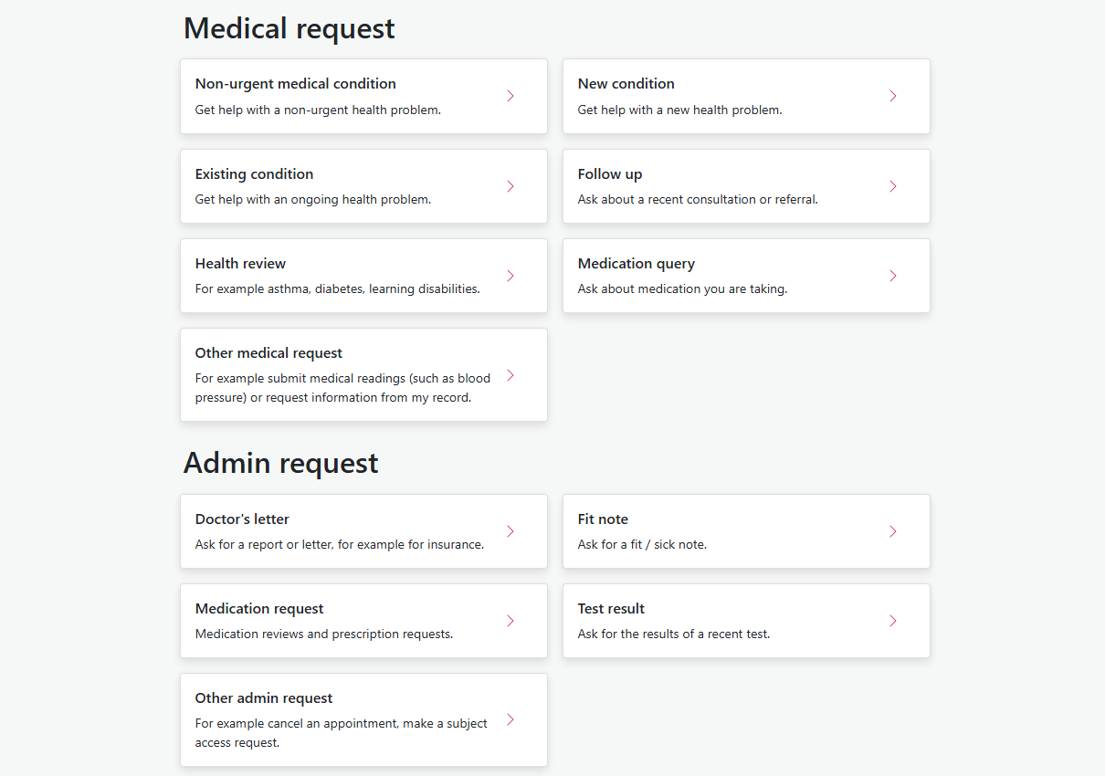
Once your request has been sent you will receive a confirmation. Our triage team will then review your request and be in touch.

